Contents
Backend Architecture 1
1. Backend Architecture Overview 1
Architecture Style 1
2. Backend Technology Selection 2
Core Stack 2
Critical Architectural Decision 3
3. Project Structure 3
4. Domain & Module Organization 4
Major Modules 4
5. API Layer Architecture 5
API Style 5
Route Structure 5
API Layer Separation 6
6. Authentication & Authorization Design 6
Authentication Strategy 6
Session Model 6
Authorization 7
7. Business Logic Layer Design 7
8. Database Access Architecture 7
Database Strategy 7
Important Tables 7
Query Strategy 8
9. Queue & Worker Architecture 9
10. Async Processing Design 9
11. Caching Strategy 10
12. File & Media Handling Architecture 10
13. AI Workflow Architecture 11
14. Event & Realtime Architecture 11
15. Error Handling Strategy 12
16. Validation Strategy 12
17. Security Architecture 12
18. Observability & Monitoring Design 13
19. Testing Strategy 13
20. Deployment & Infrastructure Strategy 14
21. CI/CD Recommendations 14
22. Performance & Scalability Analysis 15
23. Operational Risk Analysis 15
24. Production Readiness Assessment 16
25. Tradeoff Analysis 16
26. Future Backend Evolution Strategy 16

Backend Architecture

1. Backend Architecture Overview

Architecture Style
SiraFit uses a modular monolith backend architecture.
Reasoning:
- faster development velocity
- simpler operations
- easier debugging
- lower infrastructure complexity
- avoids premature distributed systems
- easier transactional consistency
- simpler local development
The system is logically modular but deploys as a unified backend service initially.
The architecture separates:
- API layer
- domain logic
- async workers
- AI orchestration
- scraping runtime
- sync engine
- persistence
- infrastructure concerns
The backend is composed of:
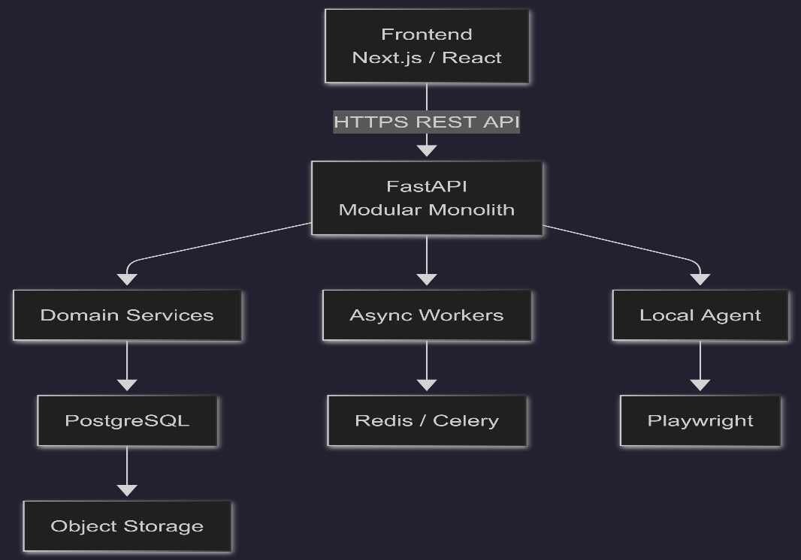

2. Backend Technology Selection

Core Stack
Layer | Technology | Purpose
API Framework | FastAPI | REST APIs
ORM | SQLAlchemy 2.0 | DB access
Validation | Pydantic v2 | Schema validation
Database | PostgreSQL | Primary OLTP store
Queue Broker | Redis | Queue transport
Workers | Celery | Background execution
Browser Automation | Playwright | Scraping/runtime
Migrations | Alembic | DB migrations
Auth | JWT + Refresh Tokens | Authentication
PDF Rendering | Jinja2 + WeasyPrint | Resume PDFs
Object Storage | S3-compatible | Generated assets
Observability | OpenTelemetry | Tracing
Metrics | Prometheus | Metrics
Logging | Structlog | Structured logging
Containerization | Docker | Deployment

Critical Architectural Decision
No Kubernetes initially.
Reason:
- operational overhead too high
- user scale too small
- distributed debugging complexity unnecessary
Deployment target:
- Docker Compose initially
- optional ECS/Fly.io/Render later

3. Project Structure
sirafit/
├── apps/
│ ├── api/
│ ├── worker/
│ ├── scheduler/
│ └── agent/
│
├── modules/
│ ├── auth/
│ ├── users/
│ ├── profiles/
│ ├── resumes/
│ ├── jobs/
│ ├── applications/
│ ├── ai/
│ ├── scraping/
│ ├── scoring/
│ ├── analytics/
│ ├── notifications/
│ ├── sync/
│ └── search/
│
├── shared/
│ ├── db/
│ ├── cache/
│ ├── config/
│ ├── logging/
│ ├── observability/
│ ├── security/
│ ├── storage/
│ ├── events/
│ ├── queues/
│ ├── errors/
│ └── utils/
│
├── infra/
│ ├── docker/
│ ├── nginx/
│ ├── scripts/
│ └── monitoring/
│
├── tests/
│ ├── unit/
│ ├── integration/
│ ├── api/
│ ├── workers/
│ └── e2e/
│
└── alembic/

4. Domain & Module Organization
Core Rule
Each module owns:
- API routes
- schemas
- services
- models
- internal business logic
Cross-module access occurs only through service interfaces.
No direct cross-module DB access.

Major Modules
Auth Module
Owns:
- login
- refresh
- token revocation
- device sessions
- RBAC
Profiles Module
Owns:
- structured resume profile
- profile versioning
- canonical user data
Jobs Module
Owns:
- normalized jobs
- deduplication state
- import lifecycle
AI Module
Owns:
- prompt execution
- schema validation
- repair loops
- provider fallback
Applications Module
Owns:
- pipeline tracking
- status transitions
- recruiter notes
Sync Module
Owns:
- operation logs
- reconciliation
- snapshots
- conflict resolution

5. API Layer Architecture

API Style
REST-first architecture.
Reasons:
- predictable
- debuggable
- frontend-friendly
- easier caching
- simpler auth boundaries

Route Structure
/api/v1/auth
/api/v1/users
/api/v1/profiles
/api/v1/jobs
/api/v1/resumes
/api/v1/applications
/api/v1/analytics
/api/v1/search
/api/v1/notifications
/api/v1/sync

API Layer Separation
Route Layer
↓
Request Validation
↓
Service Layer
↓
Repository Layer
↓
Database
Routes contain no business logic.

6. Authentication & Authorization Design

Authentication Strategy
Access Token:
- JWT
- short-lived
- 15 minutes
Refresh Token:
- rotating
- DB-backed
- revocable

Session Model
Every login creates:
device_session
Tracks:
- device_id
- IP
- user agent
- last activity
- refresh token lineage

Authorization
RBAC-lite.
Roles:
- user
- admin
Object-level ownership enforced server-side.

7. Business Logic Layer Design
Service Structure
modules/jobs/
├── service.py
├── repository.py
├── schemas.py
├── models.py
├── validators.py
└── routes.py
Service Responsibilities
Services own:
- orchestration
- validation coordination
- transaction boundaries
- retry-safe operations
Repositories own:
- query logic only

8. Database Access Architecture

Database Strategy
Primary DB:
PostgreSQL
Core Principles
- normalized OLTP schema
- JSONB only for flexible metadata
- deterministic migrations
- strong FK integrity

Important Tables
users
Stores:
- auth metadata
- preferences
- account state
profiles
Canonical structured resume data.
jobs
Stores:
- normalized jobs
- extracted metadata
- enrichment state
resumes
Stores:
- tailored resume JSON
- render artifacts
applications
Stores:
- application lifecycle
ai_generations
Stores:
- prompts
- outputs
- validation state
- retry state
sync_operations
Append-only sync log.

Query Strategy
Use:
- cursor pagination
- indexed filtering
- projection queries
- eager loading selectively
Avoid:
- ORM-heavy implicit joins
- N+1 queries
- unrestricted filtering

9. Queue & Worker Architecture
Queue Topology
Separate queues:
scraping
ai_generation
pdf_rendering
notifications
analytics
sync_repair
dead_letter
Worker Isolation
Dedicated workers per queue type.
Reason:
AI workloads must not block scraping workloads.
Retry Rules
AI Tasks
Retries:
- max 3
- exponential backoff
Scraping
Retries:
- max 5
- cooldown windows
Validation Failures
No infinite repair loops.
Single repair attempt maximum.

10. Async Processing Design
Synchronous Operations
Remain synchronous:
- login
- CRUD operations
- lightweight searches
- profile edits
Async Operations
Move async:
- scraping
- AI analysis
- resume generation
- PDF rendering
- analytics aggregation
Async Job Lifecycle
PENDING
RUNNING
COMPLETED
FAILED_RETRYABLE
FAILED_FINAL
No hidden retry recursion.

11. Caching Strategy
Redis Usage
Use Redis for:
- rate limiting
- queue transport
- hot cache
- short-lived search cache
Cache Rules
Cache only:
- expensive reads
- analytics summaries
- search results
Never cache:
- authorization decisions
- mutable profile writes

12. File & Media Handling Architecture
Object Storage
Use S3-compatible storage.
Stores:
- PDFs
- generated resumes
- exported files
Upload Rules
Allowed:
- PDF
- DOCX
- TXT
Virus scanning:
- async ClamAV worker
Signed URLs:
- short-lived
- private-by-default

13. AI Workflow Architecture
AI Boundary
AI cannot:
- mutate authoritative state directly
- bypass validators
- control workflows
AI only produces candidate structured outputs.
AI Pipeline
Input Context
↓
Prompt Builder
↓
Provider Execution
↓
Schema Validator
↓
Repair Attempt
↓
Persistence
Provider Model
User-supplied Gemini API keys initially.
Future:
- provider abstraction
- OpenAI fallback
- Anthropic support

14. Event & Realtime Architecture
Event Model
Internal domain events only.
No Kafka initially.
Realtime
Use lightweight WebSockets for:
- job progress
- batch status
- notifications
Fallback:
- polling

15. Error Handling Strategy
Standard Error Format
{
"error": {
"code": "VALIDATION_ERROR",
"message": "Invalid resume schema",
"request_id": "req_123"
}
}
Centralized Exception Middleware
Handles:
- validation
- auth failures
- rate limits
- internal errors
No raw stack traces exposed.

16. Validation Strategy
Validation Layers
API Validation
Pydantic request validation.
Domain Validation
Business rule validation.
AI Validation
Schema enforcement.
Scraping Validation
Extraction anomaly detection.

17. Security Architecture
Core Security Measures
- JWT auth
- refresh rotation
- password hashing
- RBAC
- CSRF protection
- input sanitization
- SQL parameterization
- signed uploads
- audit logging
Secrets
Environment-managed secrets only.
No secrets in repo.

18. Observability & Monitoring Design
Logging
Structured JSON logs.
Fields:
- request_id
- user_id
- job_id
- worker_id
- trace_id
Metrics
Track:
- API latency
- queue depth
- retry rates
- AI failures
- scraping failures
- sync lag
Tracing
OpenTelemetry tracing:
- API
- DB
- queue
- AI execution

19. Testing Strategy
Unit Tests
Focus:
- validators
- services
- scoring logic
Integration Tests
Test:
- DB interactions
- queue execution
- auth flows
E2E Tests
Test:
- resume generation
- scraping pipelines
- application workflows

20. Deployment & Infrastructure Strategy
Initial Deployment
Docker Compose:
- api
- worker
- postgres
- redis
- nginx
Environments
- local
- staging
- production
Strict config isolation.

21. CI/CD Recommendations
CI Pipeline
Run:
- lint
- type checks
- tests
- migrations validation
- security scans
CD
Initial:
- manual approval deploys
Reason:
safer operational control early.

22. Performance & Scalability Analysis
Hot Paths
Most expensive:
- AI generation
- semantic search
- scraping
Scalability Strategy
Scale independently:
- API replicas
- workers
- scraping runtimes
DB remains centralized initially.

23. Operational Risk Analysis
Highest Risks
Retry Storms
Mitigation:
- retry caps
- cooldowns
- DLQs
Scraper Drift
Mitigation:
- extraction validators
- quarantine buckets
AI Cost Explosion
Mitigation:
- strict idempotency
- caching
- batch throttling
Sync Corruption
Mitigation:
- snapshots
- replay boundaries
- reconciliation repair

24. Production Readiness Assessment
Current architecture is suitable for:
- 100–1,000 active users
- moderate async workloads
- moderate scraping volume
The architecture is operationally realistic for:
- solo founder
- small engineering team

25. Tradeoff Analysis
Why Modular Monolith
Chosen over microservices because:
- simpler debugging
- lower ops cost
- easier transactions
- faster iteration
Why REST Instead of GraphQL
- simpler caching
- easier contracts
- lower frontend complexity
Why Redis + Celery
Operationally mature.
Easy to debug.
Sufficient for current scale.

26. Future Backend Evolution Strategy
Future evolution paths:
Likely Future Extractions
Possible later separation:
- AI orchestration service
- scraping cluster
- analytics pipeline
Not Needed Initially
Avoid:
- Kubernetes
- Kafka
- event sourcing everywhere
- distributed SQL
- CQRS overengineering
Evolution Rule
Scale only when:
- operational pain is measurable
- bottlenecks are observable
- metrics justify complexity

